Hi :) Here are some helpful websites that we have used when we first started with glmer/odds ratios. No need to use them, just thought it might help if clarification is needed.

glmer:

<https://www.introranger.org/post/glm-glmm/#analyzing-non-independent-data>

<https://data.library.virginia.edu/getting-started-with-binomial-generalized-linear-mixed-models/>

<https://www.mathworks.com/help/stats/generalized-linear-mixed-effects-models.html>

<https://search.r-project.org/CRAN/refmans/lme4/html/glmer.html>

<https://www.rdocumentation.org/packages/lme4/versions/1.1-31/topics/glmer>

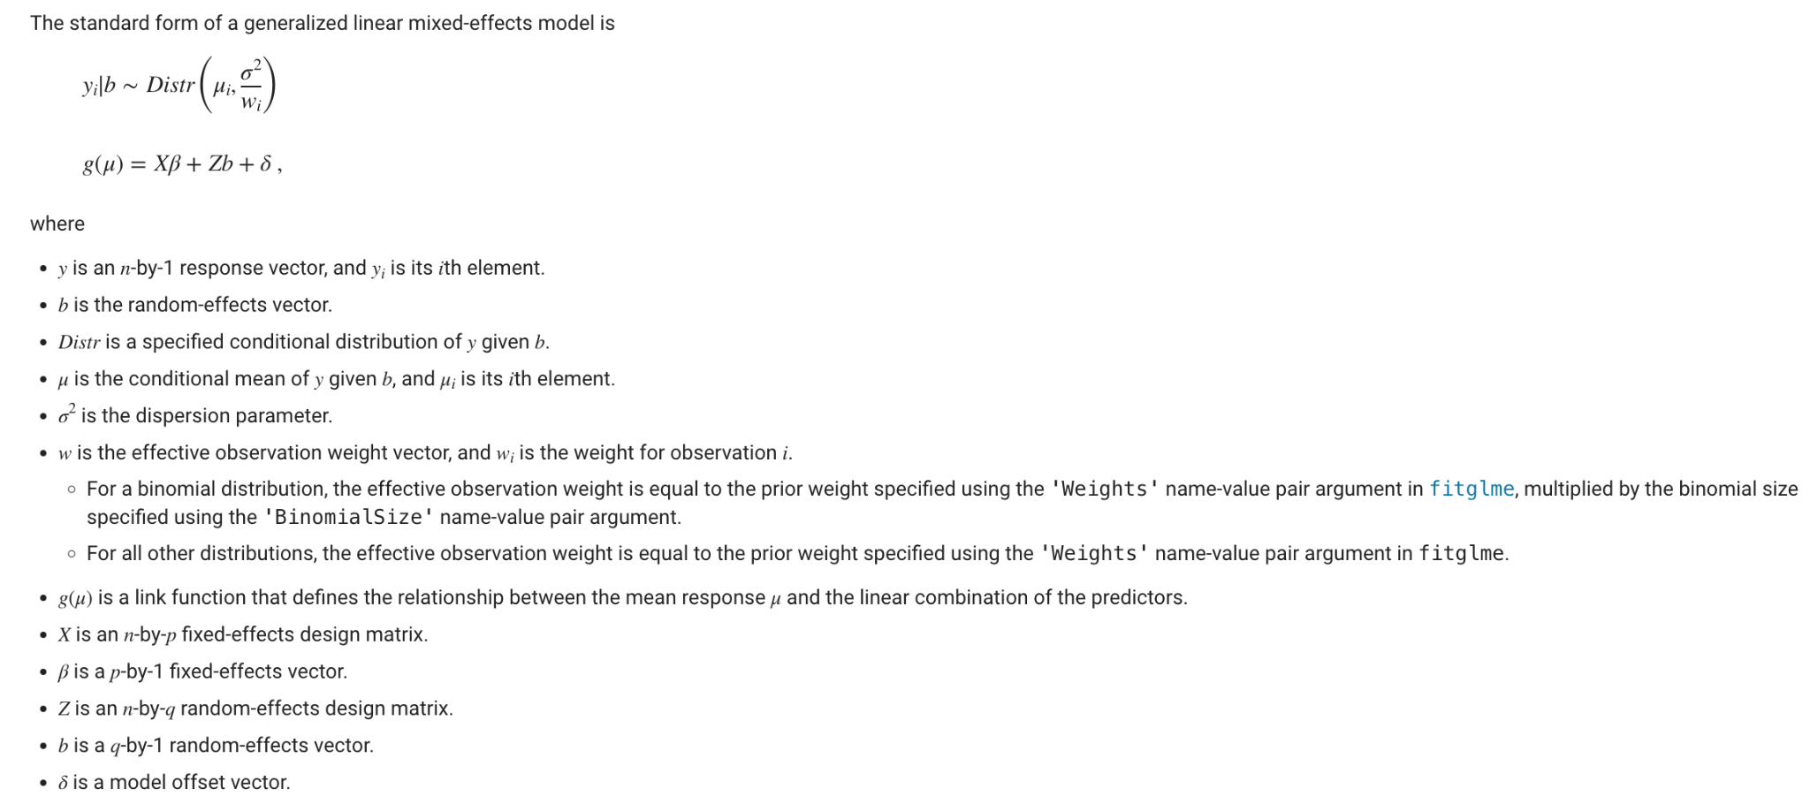

odds ratios:

<https://www.cdc.gov/training/SIC_CaseStudy/Interpreting_Odds_ptversion.pdf>

<https://stats.oarc.ucla.edu/other/mult-pkg/faq/general/faq-how-do-i-interpret-odds-ratios-in-logistic-regression/>

<https://statisticsbyjim.com/probability/odds-ratio/>

<https://www.statisticssolutions.com/odds-ratio/>